<https://learn.acloud.guru/course/93e6884d-ac98-49b6-a9cd-5e357d2dbb41/dashboard>

Chapter 6

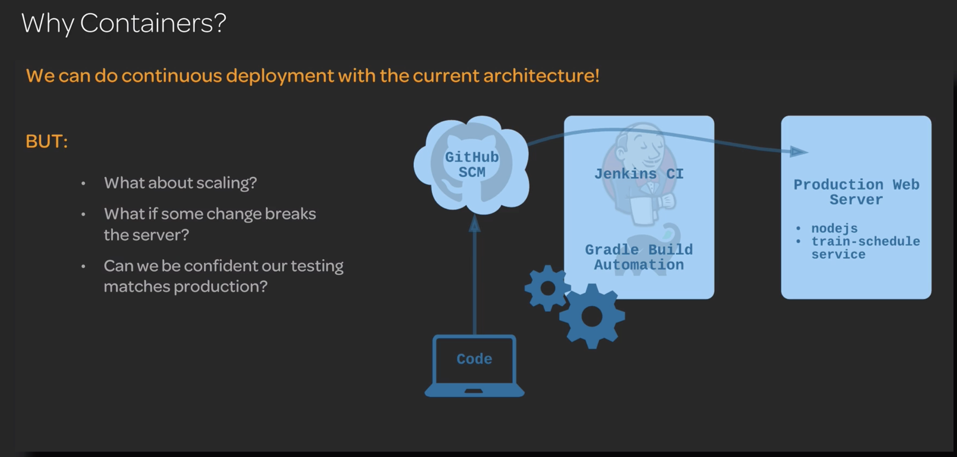

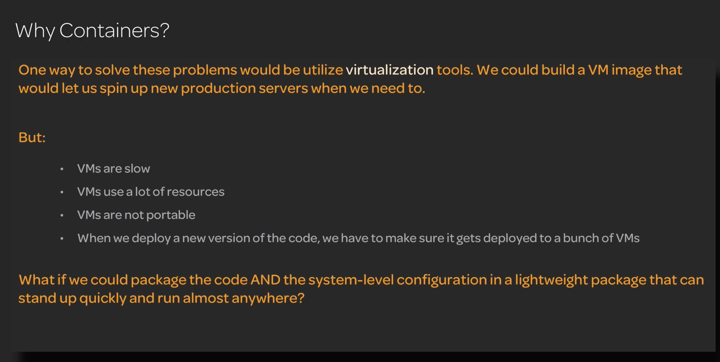

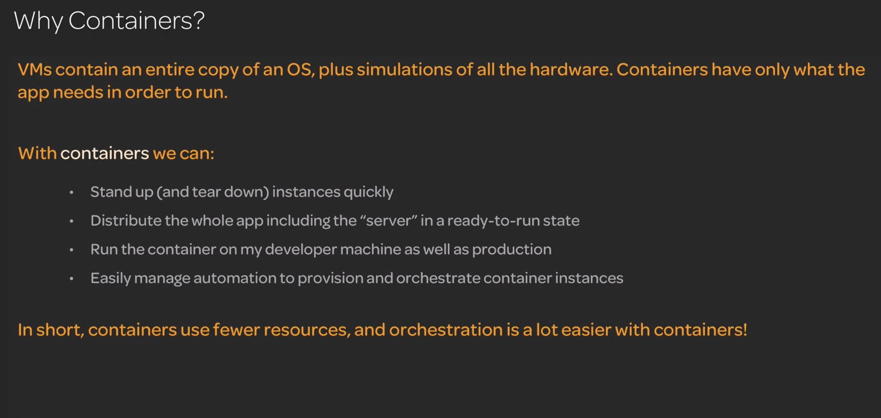

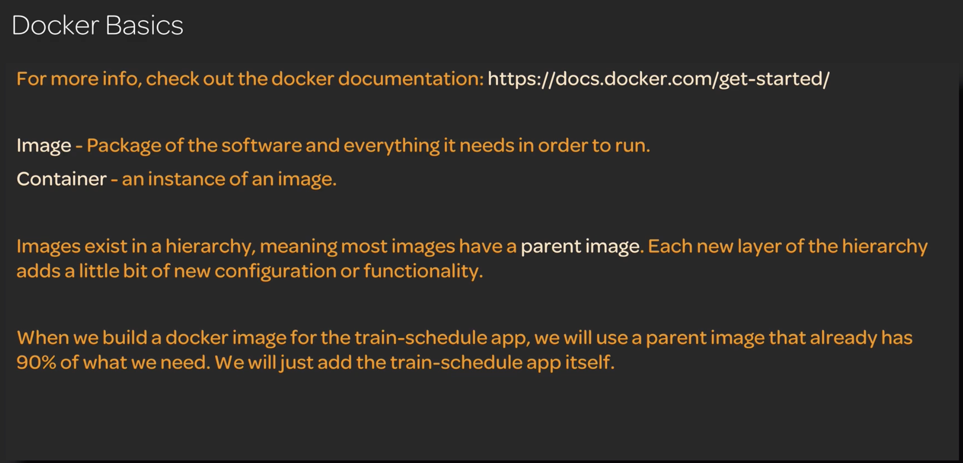

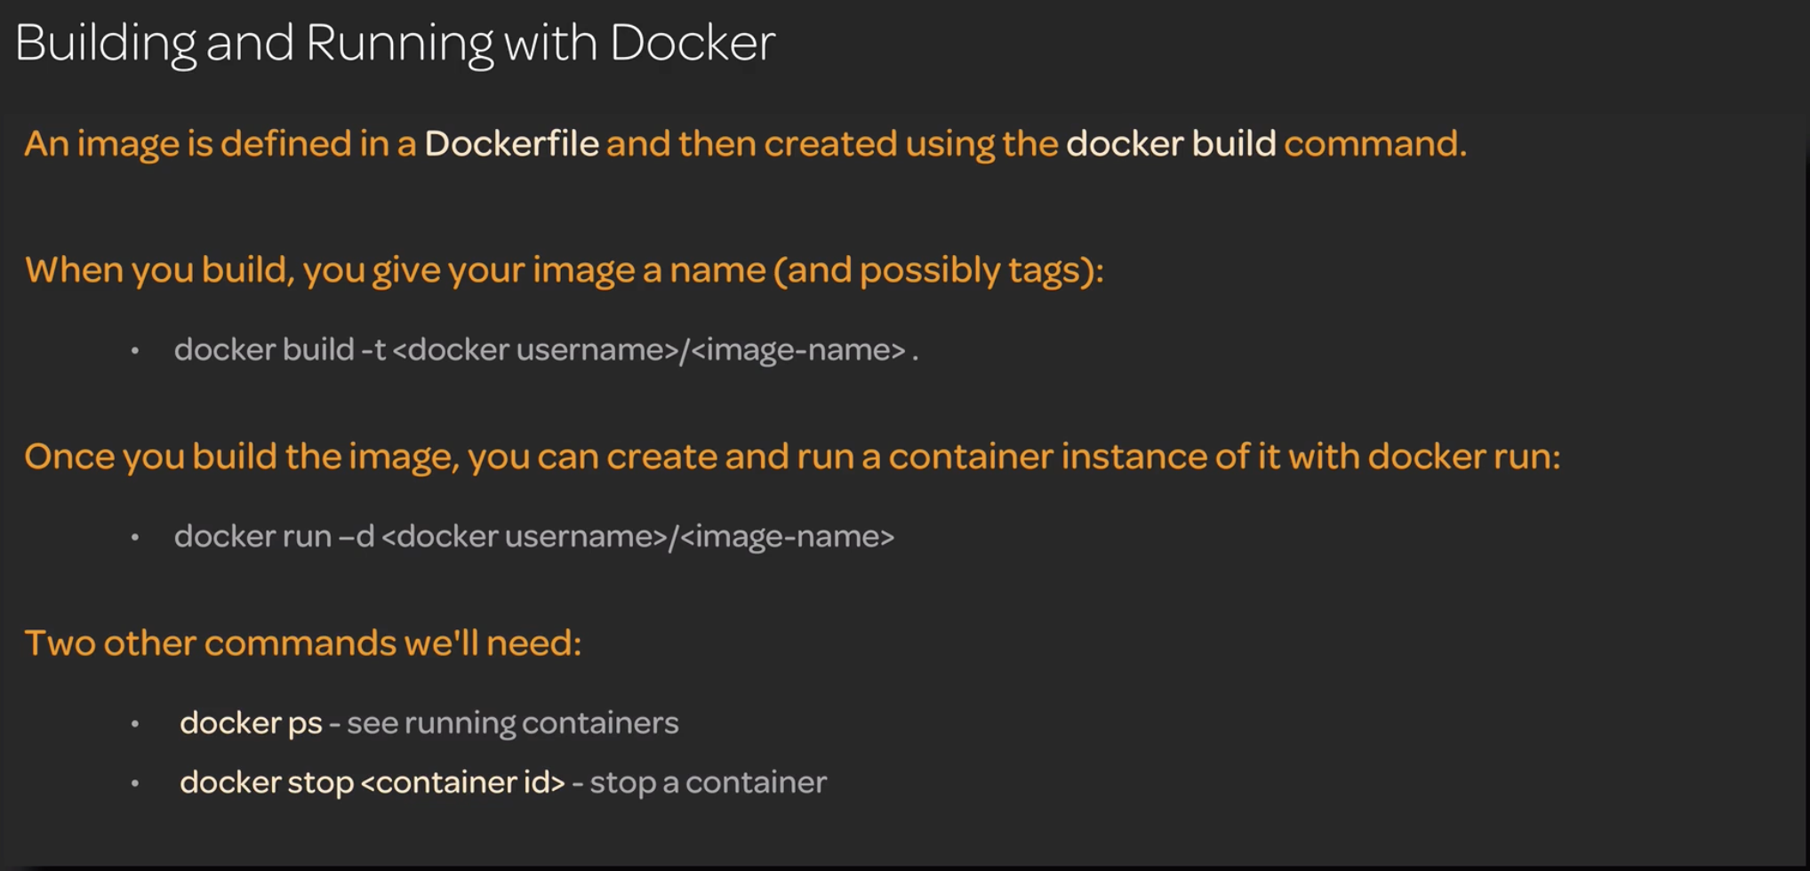

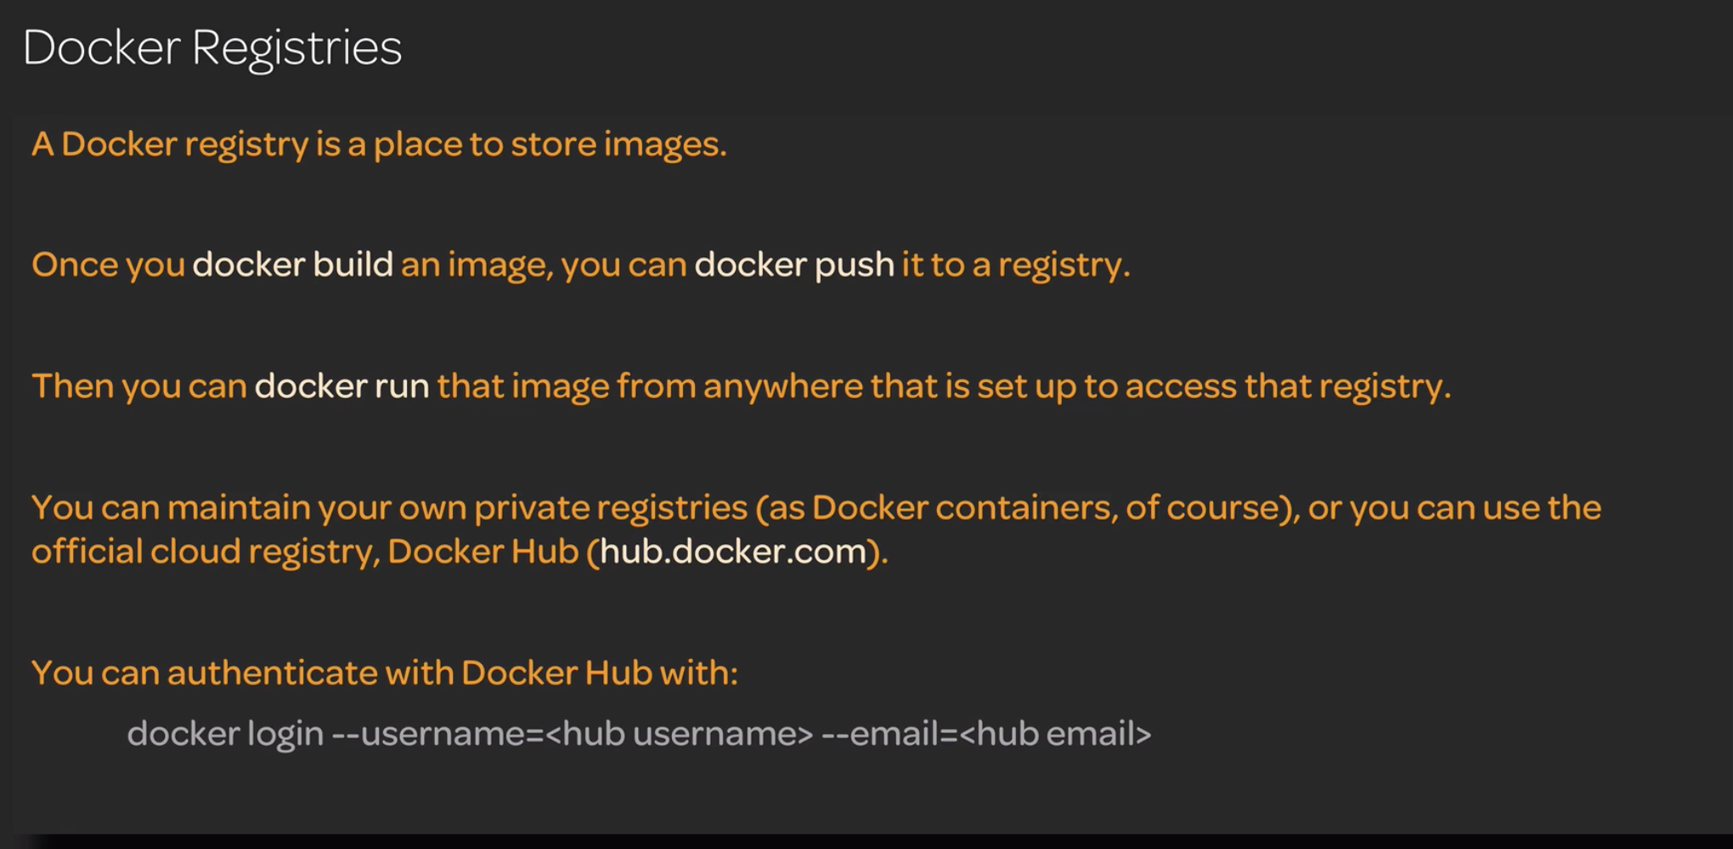

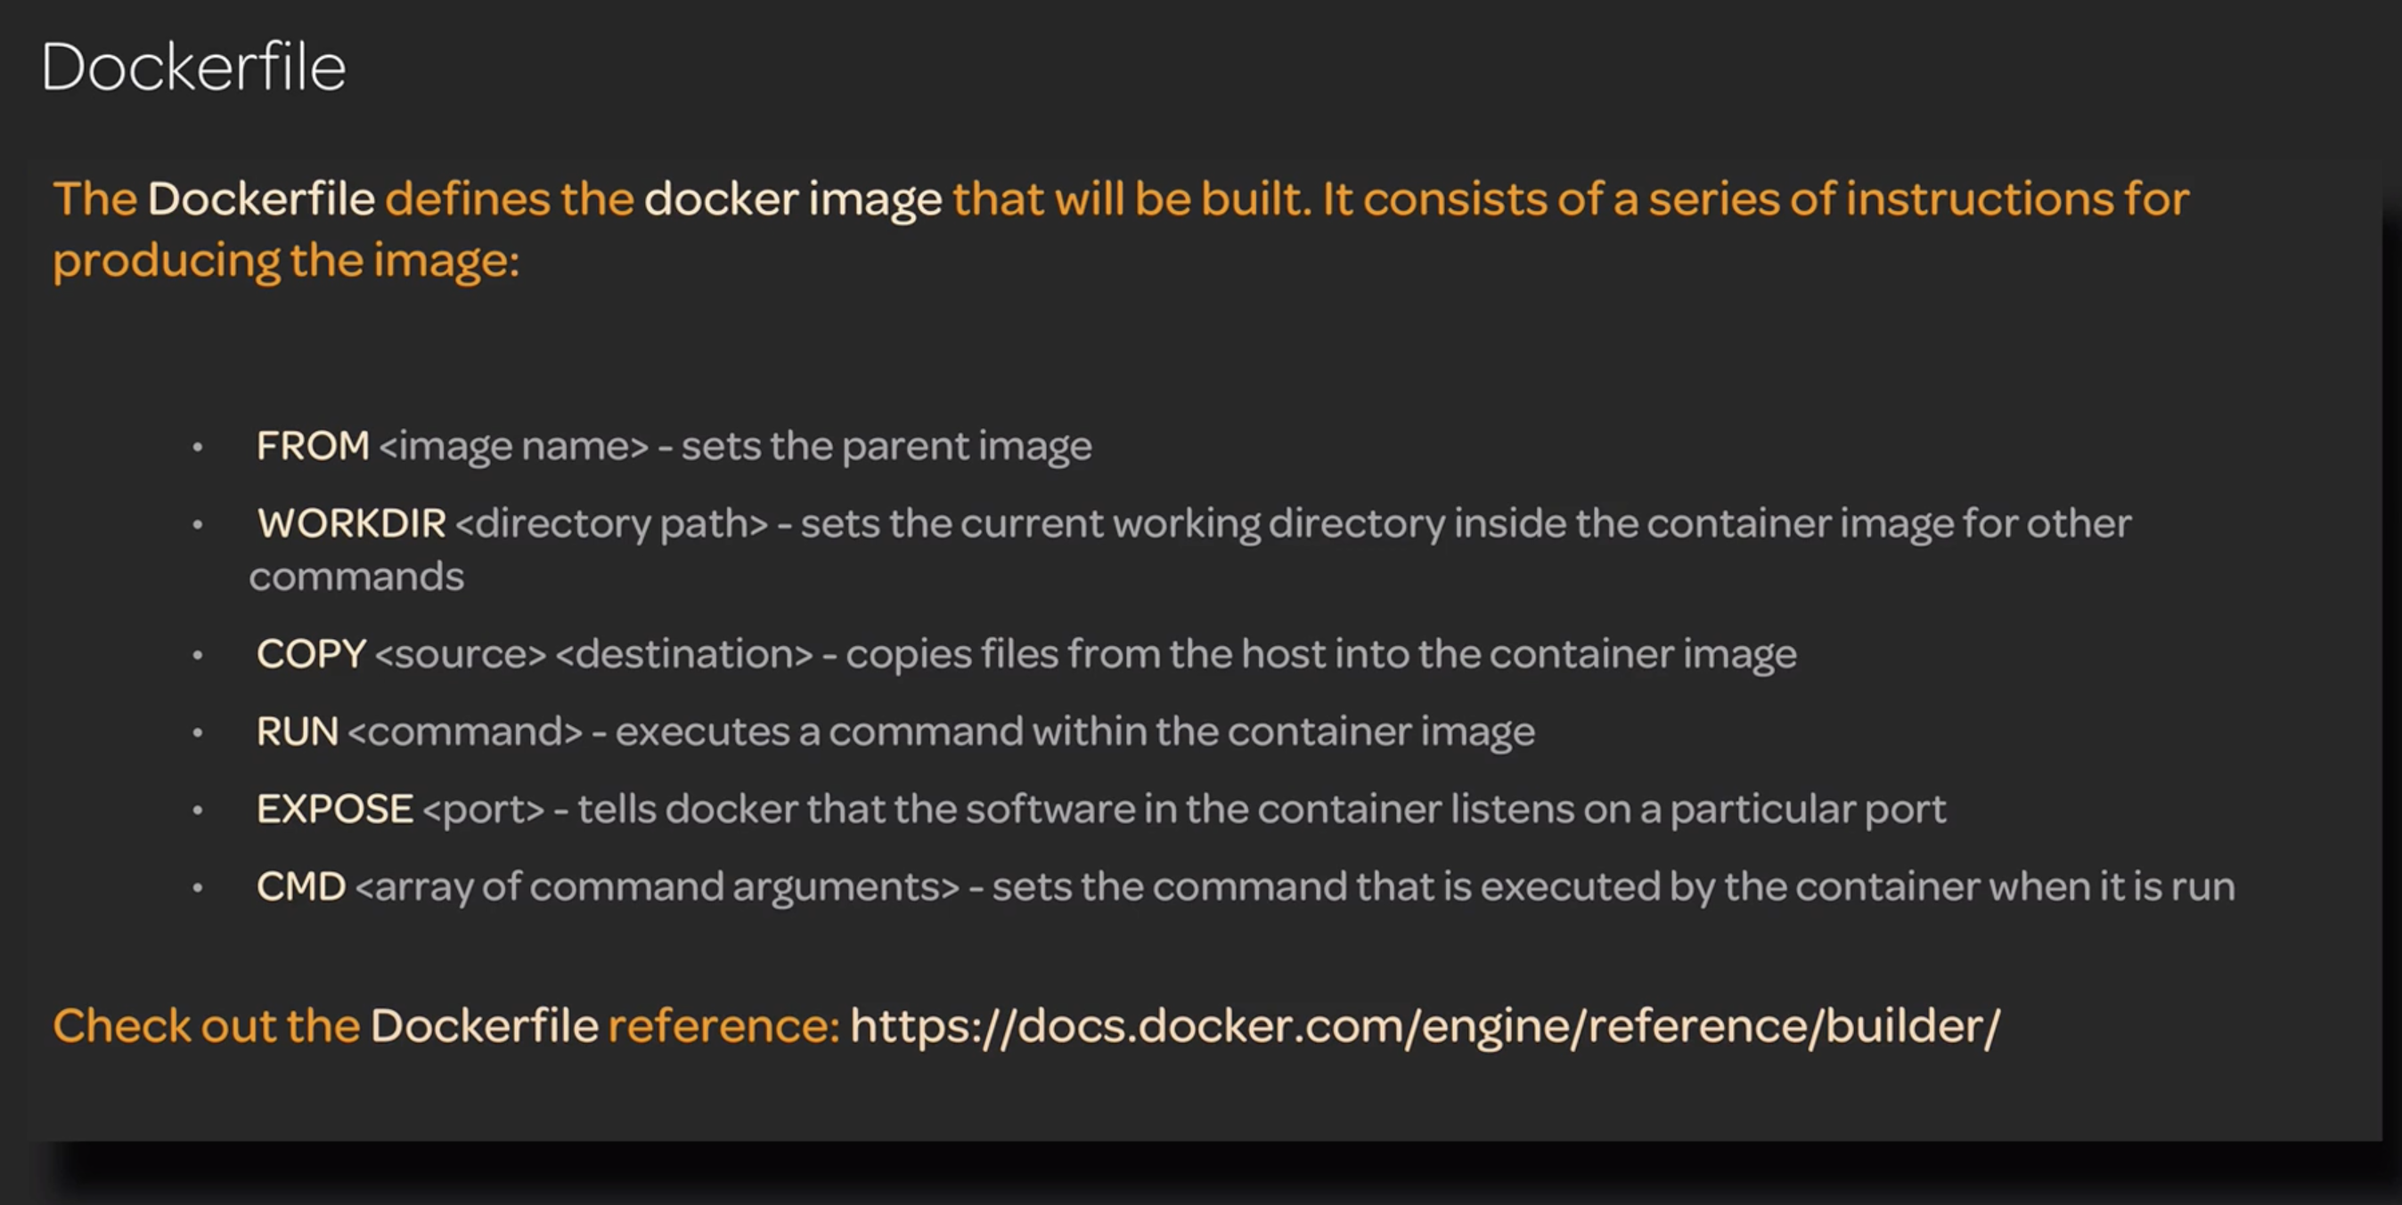

DOCKERIZING AN APP

PROJECT ran the build in a container using Dockerfile and installing npm on the container

This we ran the app in Gradle lesson by installing npm inside the gradle wrapper and starting check gradle lesson

<https://github.com/Dheeraj-Nagireddy/cicd-pipeline-train-schedule-docker.git>

* git clone this project into the docker host and execute the below commands

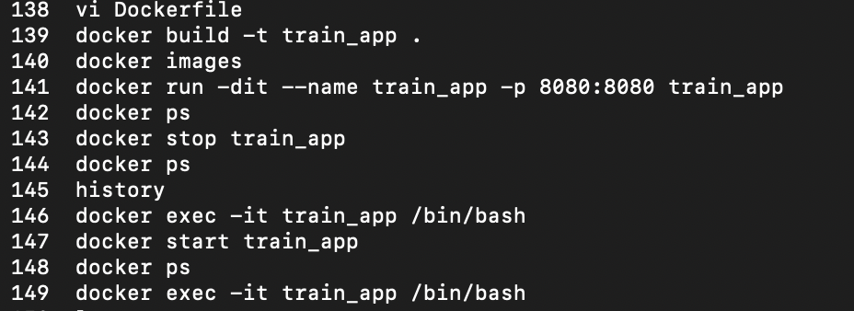

Dockerfile:

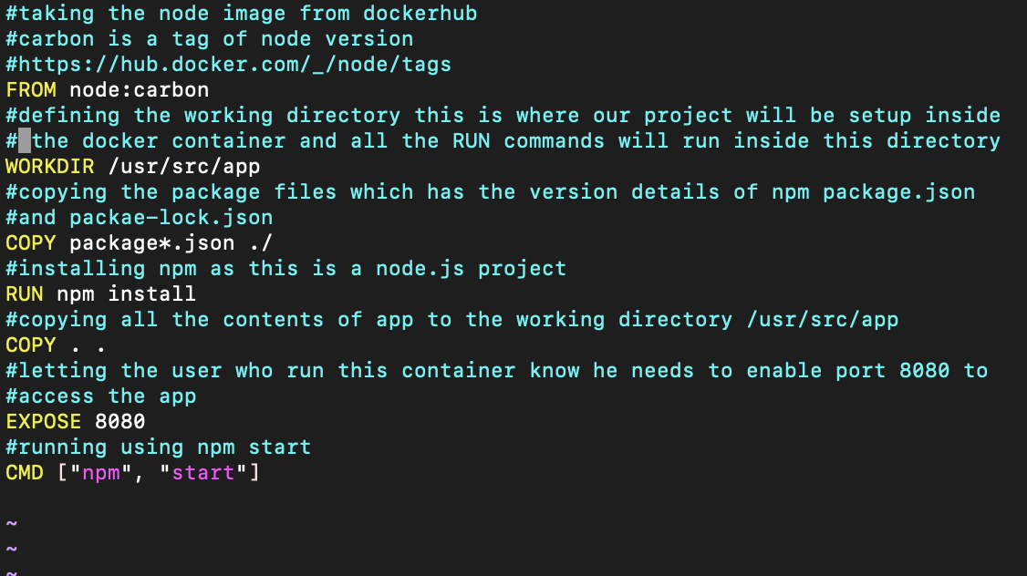

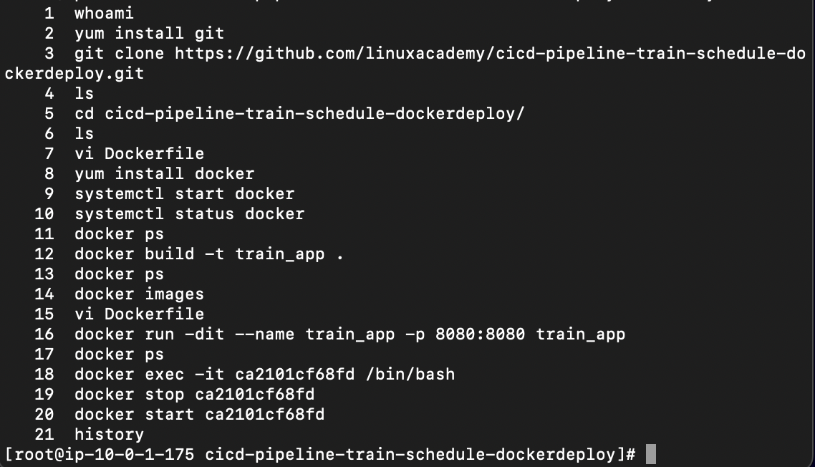

If you are doing this on a Jenkins server you need to change the nodejs port in nodemodules

>Cd into the workspace of Jenkins>the project folder>nodemodules>find . -name “server.js”

>edit the port 8080

./request/node_modules/hawk/lib/server.js the server.js was in this folder before

>build a image with the new modules created

>docker build -t image_name .(Dockerfile_directory)

>run the image

>docker run -dit -name container_name -p 8888:9999 image_name

8888 is the app access name we need to enable the port for

9999 is the changed value of nodejs default port 8080

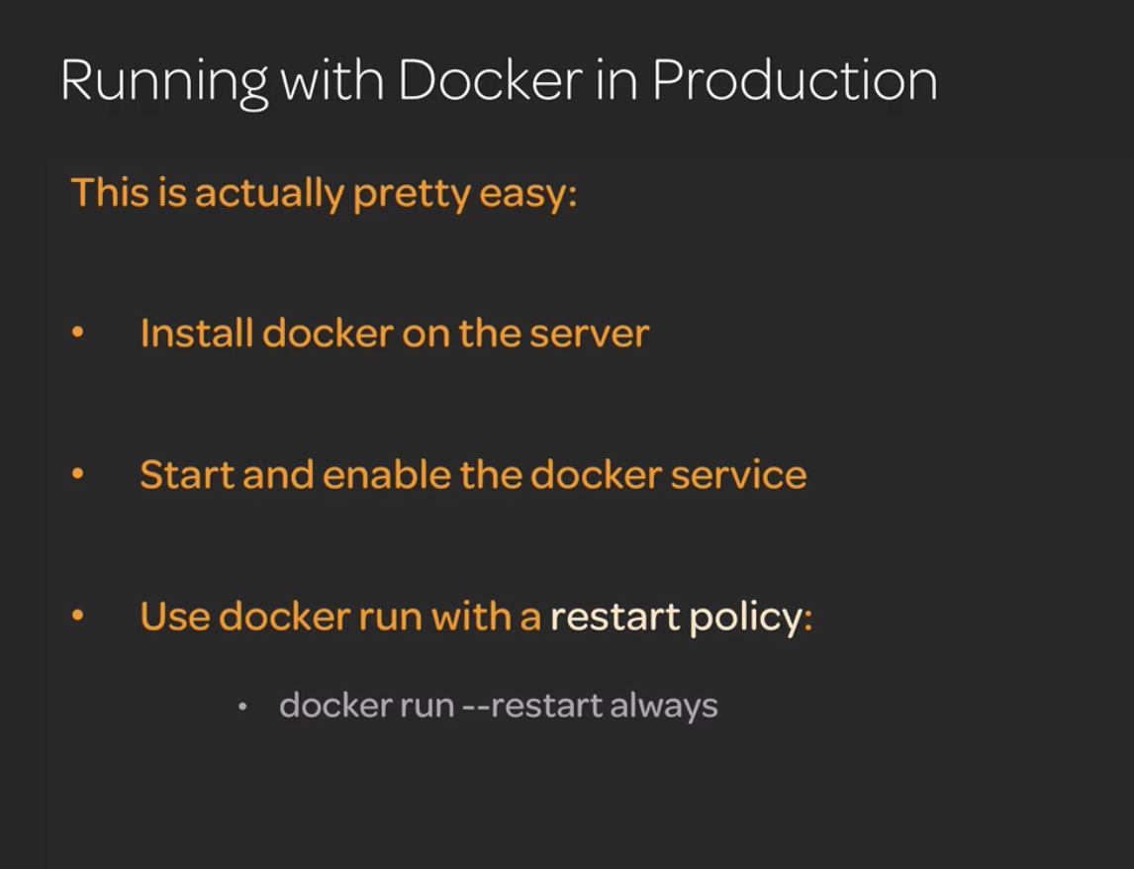

DOCKER IMPLEMENTATION WITH JENKINS PIPELINE

To implement Docker with Jenkins pipeline we need to install docker on Jenkins server and give the Jenkins user the docker permission to execute the docker commands

ADDING Jenkins User to docker group so Jenkins can run docker commands implemented in the CI/CD

Creating a group called docker, docker will automatically pickup this

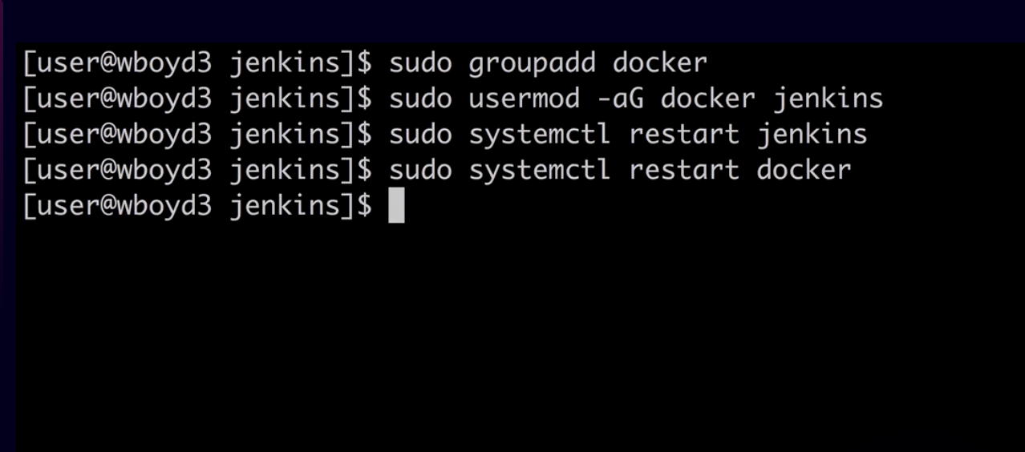

This was the current state till before docker integration in CI/CD pipeline

Github integrates with Jenkins using github hooks and integrates the code continuously and build its using Gradle by using a Jenkinsfile inside the repo and deploys it to production

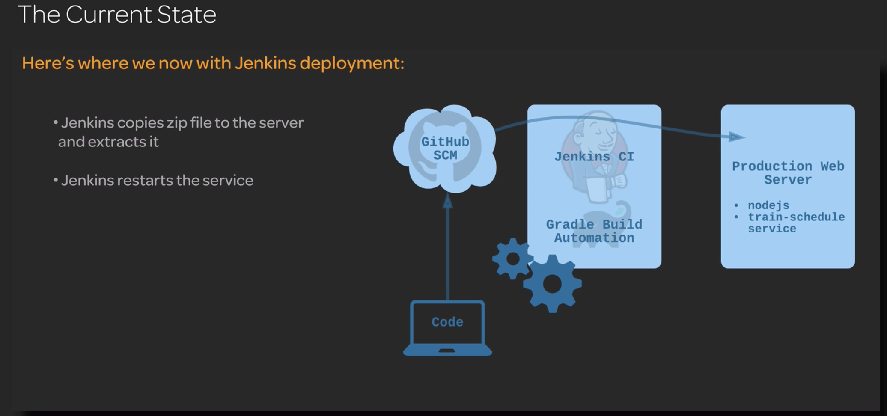

What we are implementing with docker

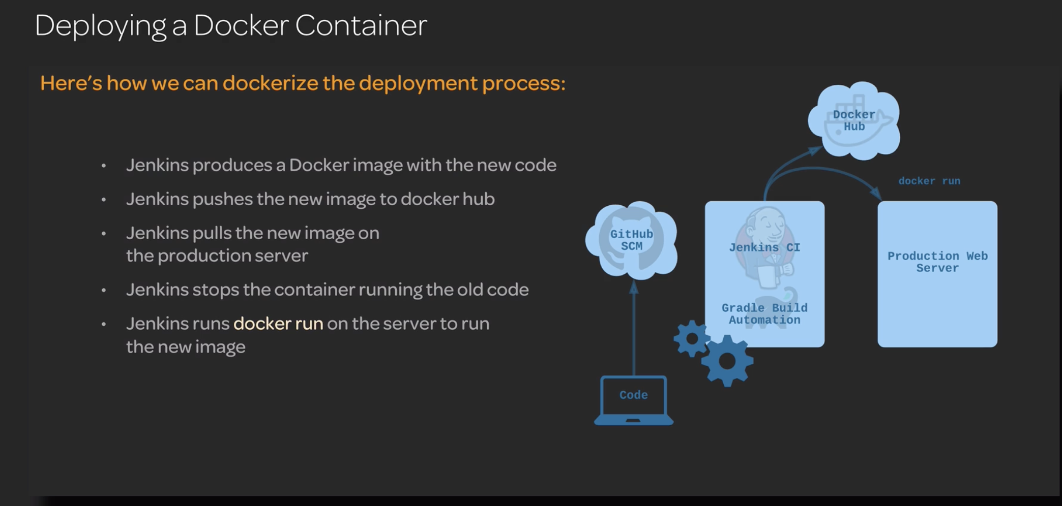

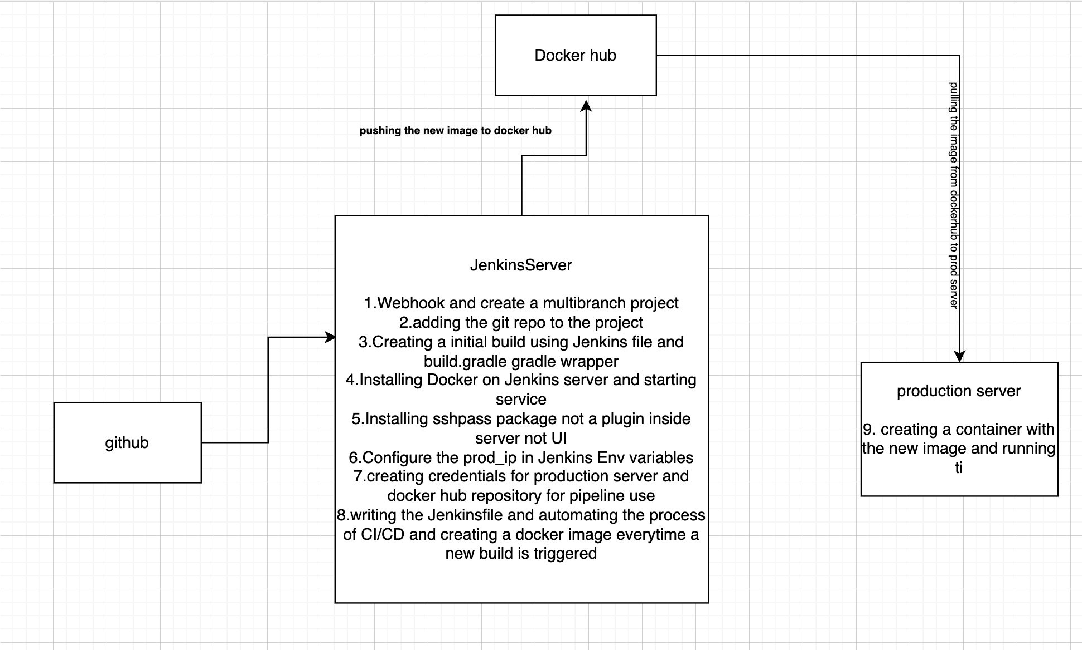

Every time a new code is integrated it will build it and creates a images and push it to docker hub. The image created is pulled into the production servers and the old app is removed and run the newly built image.

We can even run the app inside production servers by using the docker image pulled but we have to install the docker in prod server and docker run the container image

Adding the prod server inside environmental variables to reuse just the id inside the pipeline

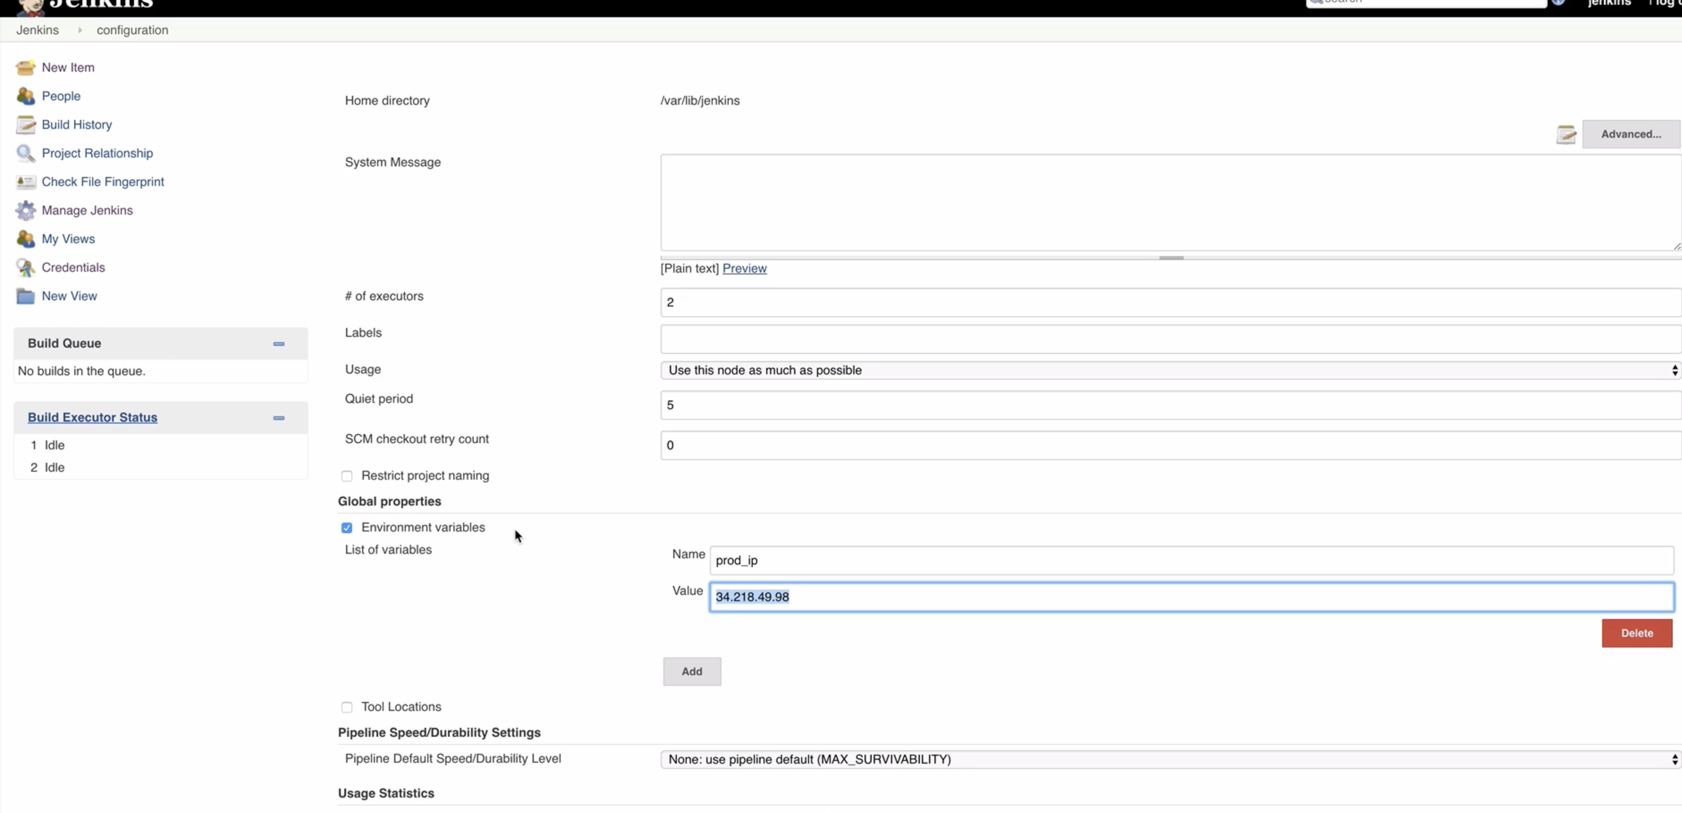

Created a set of credentials to login inside the production server and docker hub login to push the images to our repository

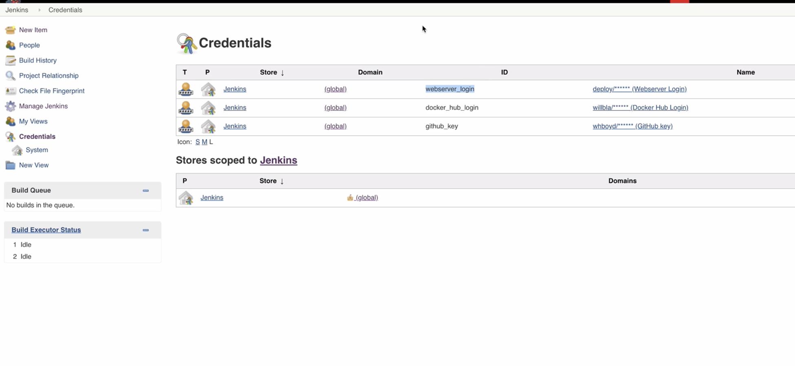

Project repo <https://github.com/linuxacademy/cicd-pipeline-train-schedule-dockerdeploy.git>

Intial Jenkins file which implements automation build using webhooks and gradle build

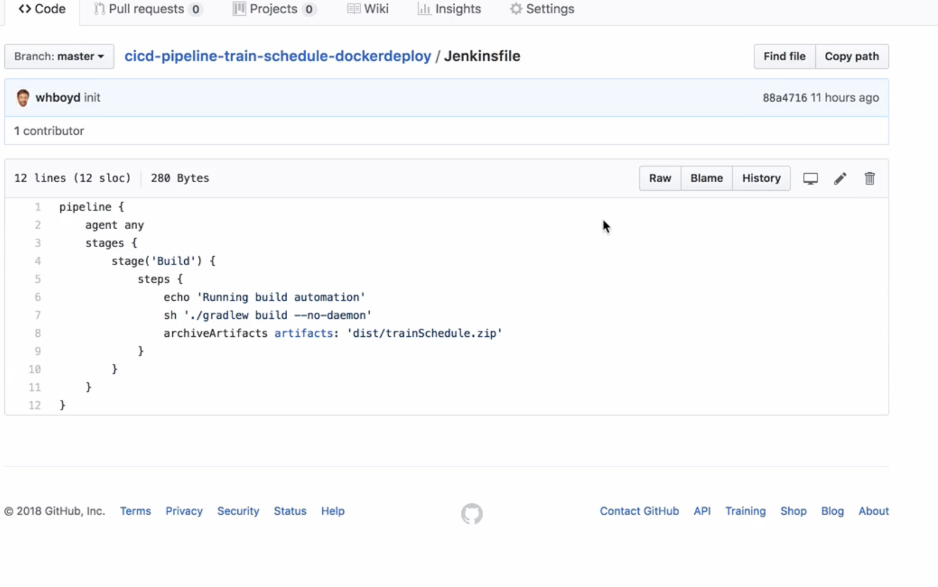

Jenkinsfile in example solutions and local repo /Users/dheeraj/Desktop/Projects/Class Notes/Devops Notes/Jenkins/Pipeline/Jenkinsfile (chp5-continous delivery)

Sshpass used in the deploy to production stage is a package in linux not Jenkins plugin

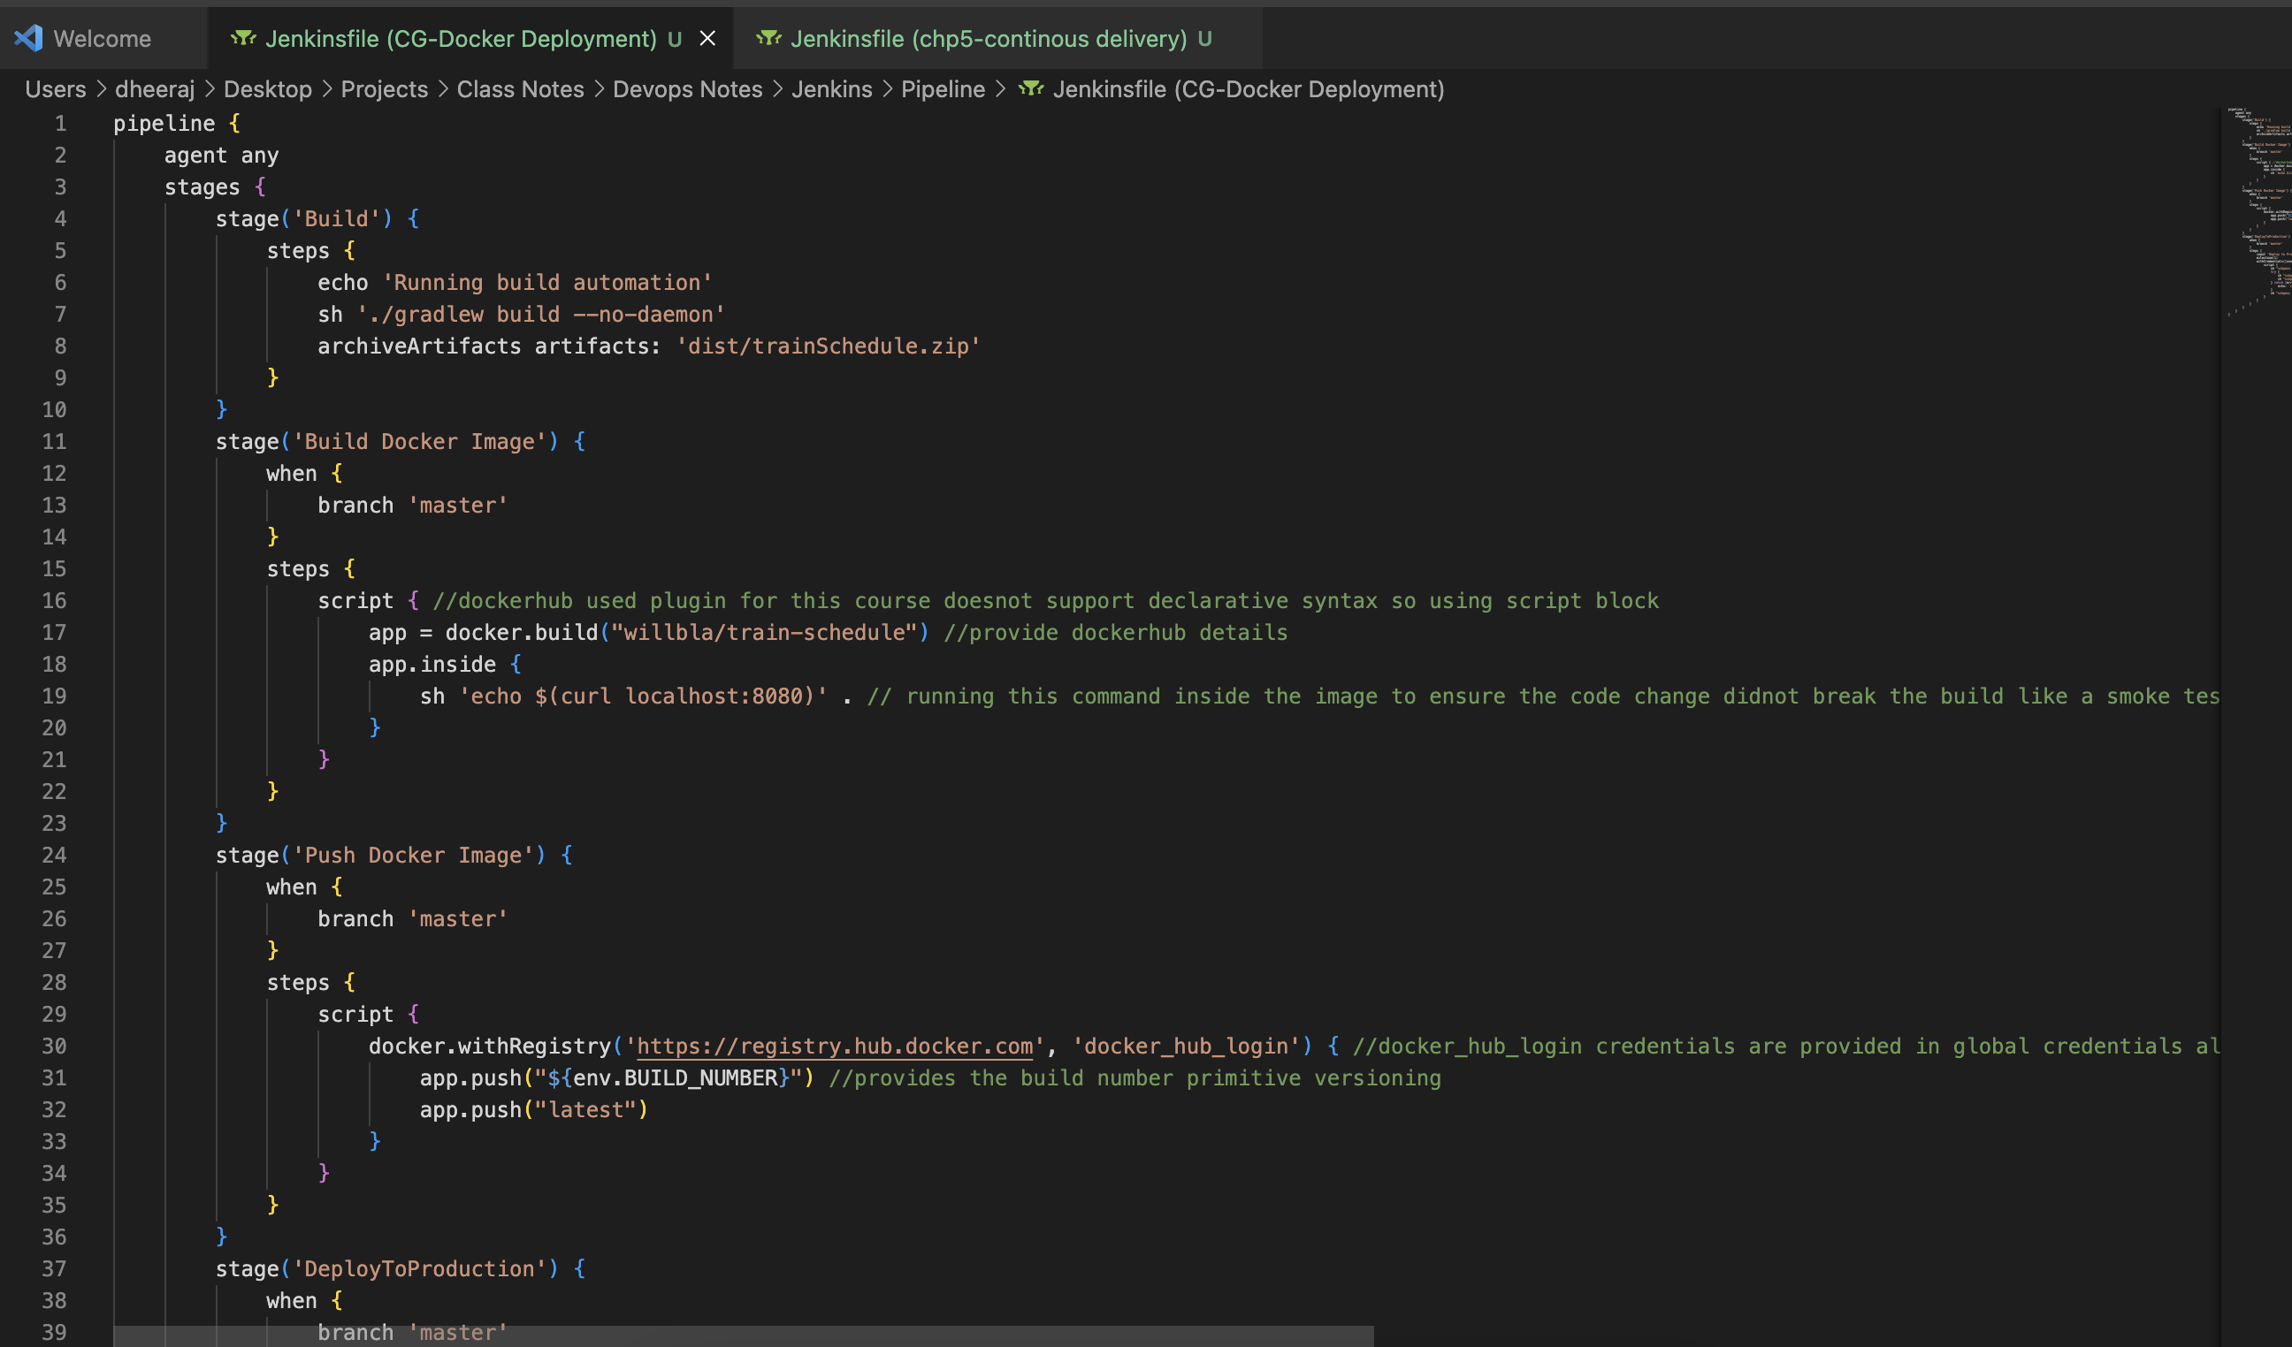

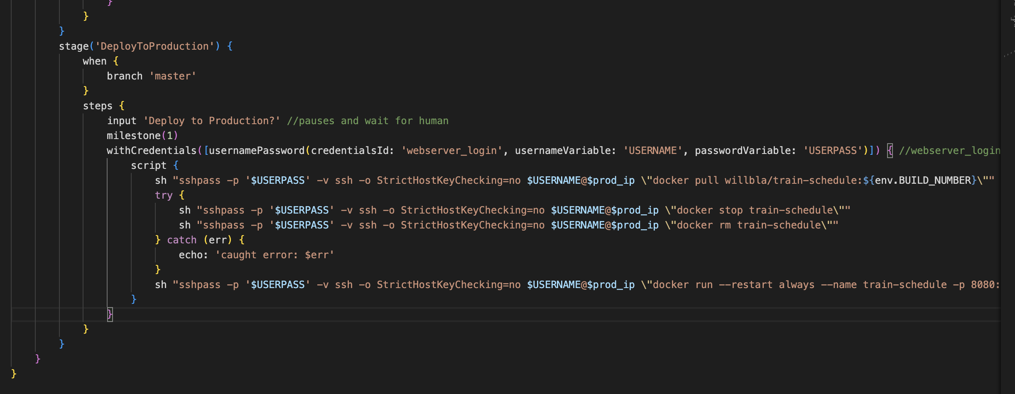

RAN the project in declarative pipeline without any plugins

>checkout from git

>Build the code using gradle wrapper ./gradlew build

>Deploy the zip archive file to production using scp

>Built a image from Dockerfile inside the production server

> Ran the image created and pushed it to dockerhub

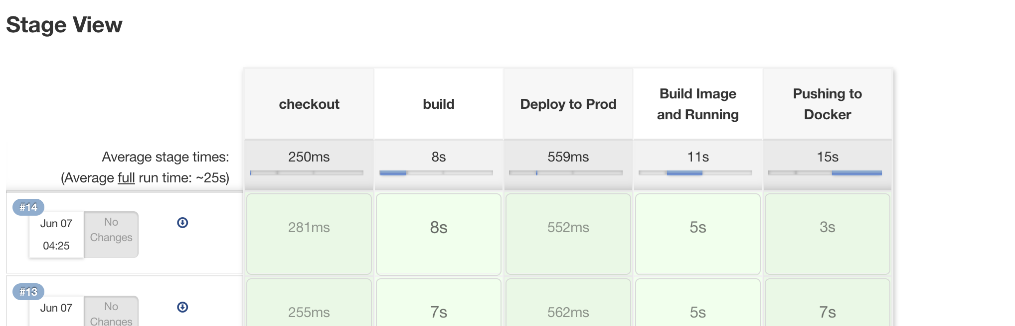

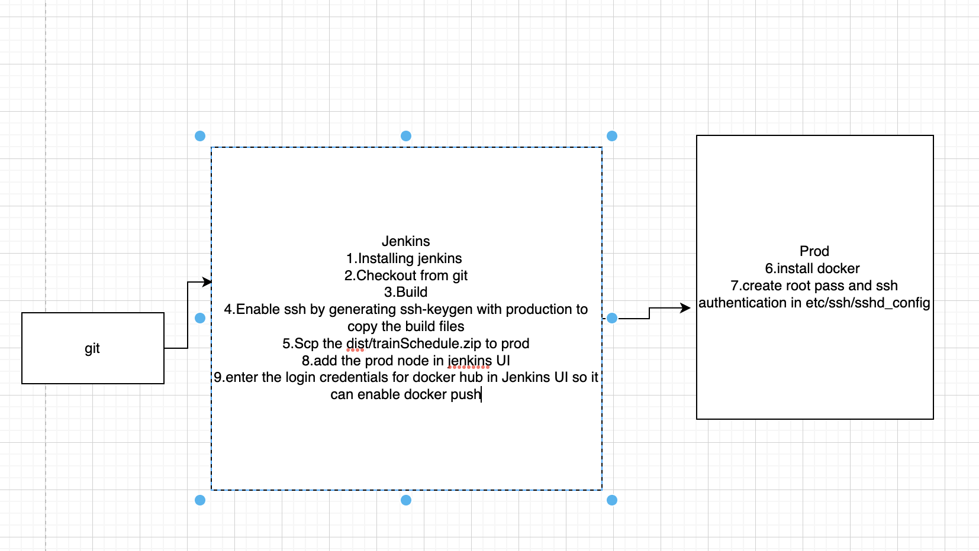

Pipeline file in ClassNotes>Devops Notes>Jenkins>Jenkins Prod and docker push